Application of ion mobility and tandem mass spectrometry for the elucidation of thiolyne-comb polymer architectures
Kayla Williams-Pavlantos¹, Brennan Curole², Scott Grayson², and Chrys Wesdemiotis¹
- The University of Akron, Akron, Ohio, United States
- Tulane University, New Orleans, Louisiana, United States
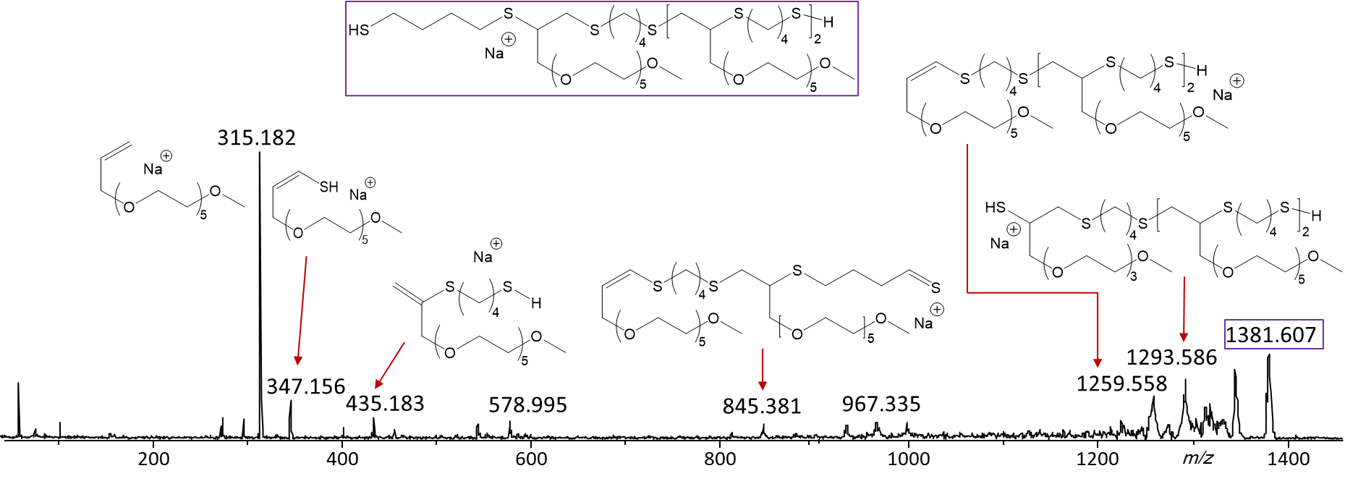
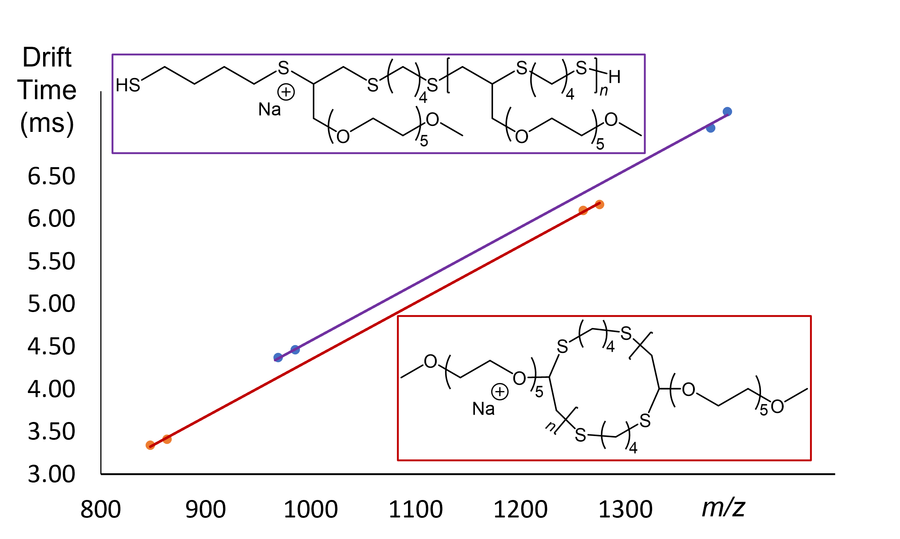
Ion mobility spectrometry (IMS) and tandem mass spectrometry (MS/MS) were utilized to characterize copolymers synthesized via thiol-yne chemistry and composed of a poly(thioether) main chain with poly(ethylene oxide) pendants. The product was expected to contain copolymers with several different architectures. ESI-MS/MS identified low-mass tadpole species which gave rise to three structurally characteristic fragments all arising by dissociations in the tadpole tail. Similar analysis of the heavier oligomers led to fragmentation patterns diagnostic of unsaturated comb structures. MALDI-MS/MS analysis of dithiol terminated samples, which are saturated and thus confined to comb structures with a linear main chain, showed very similar fragmentation spectra as the previous unsaturated thiol-yne comb polymers, indicating the need for additional analysis methods to differentiate between linear and cylic copolymer architectures. Using IMS, drift time data for both the saturated and unsaturated combs were obtained. The unsaturated comb polymers consistently show lower drift times than their linear saturated congeners, indicating that the unsaturated product had undergone cyclization to form a macrocyclic poly(thioether)main chain.
MALDI-MS/MS of saturated thiol-yne 3-mer
Comparison of drift times obtained from IMS analysis of saturated and unsaturated thiol-yne comb polymers

