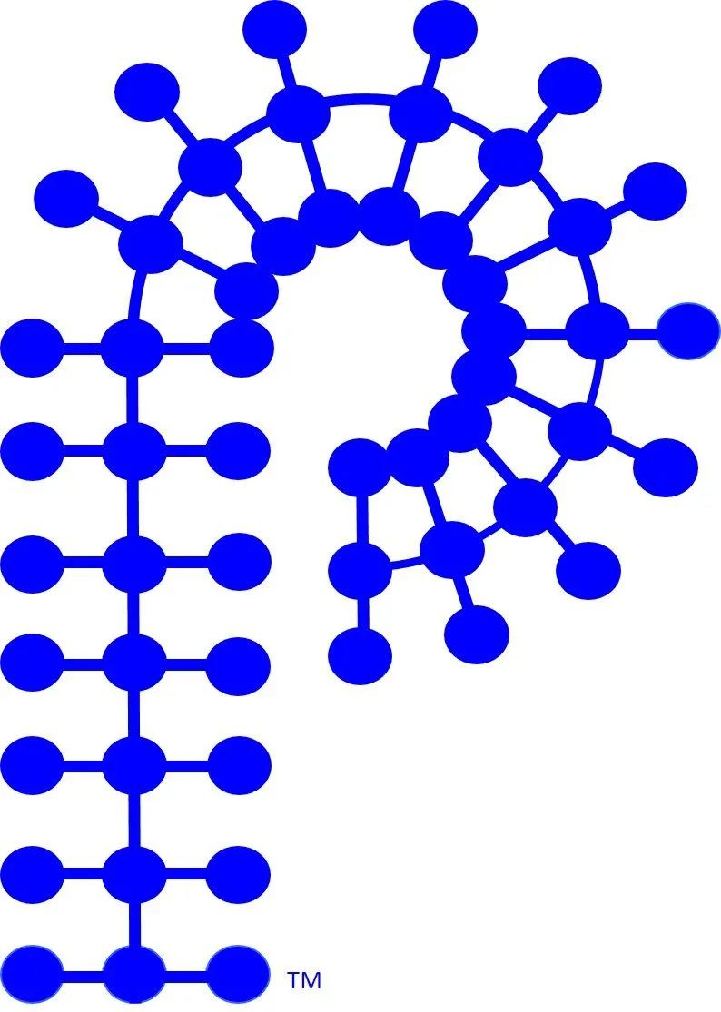

Division of Polymer Chemistry
Business Meeting Agenda
Sunday, March 23, 2025–12:00pm – 02:00pm (In-Person)
Marriott Marquis San Diego: Room – Rancho Santa Fe 1/2

12:00pm Lunch Begins

12:15pm Welcome, Introductory, Remarks Laura Stratton, Chair

12:20pm ACS Programming & Professional Relations Derek Patton, Chair-Elect
National Meetings Kalow / Savage / Collier / Haase
Industrial Advisory Board Jeff Ting / Michael Sims
Awards Committee Toby Nelson

12:40pm Meetings, Workshops, & International Hayley Brown, Vice-Chair
Regional & Other Meeting Support Ying Yang
Workshop Committee Beth Elacqua
Webinars Tomonori Saito
International Committee Rigoberto Advincula

1:00pm Outreach & Education Dawanne Poree, Past Chair
Review Elections/Call for Nominations Allan Guymon / Semra Colak Atan
MACRO Update Phil Costanzo

1:15 Secretary Justin Kennemur
Board Minutes-Approval Justin Kennemur
Website/Publicity Tayler Hebner

1:30pm Member Outreach Piril Ertem, Member-at-Large
Membership Piril Ertem
Student Chapters Kaitlyn Crawford

1:40pm POLY Finances John Matson, Treasurer
Treasurer Report/Business Office John Matson

1:50pm Councilors Report Mary Ann Meador / Brian Long
Greg Tew / Kathryn Uhrich

02:00pm Adjourn

