ACS POLY Abstract Submission
Title: Structural control and high-throughput FRAP analysis of solute diffusion in hydrogels
Abstract: (Limit 1940 characters, 230 words)
A drug or protein’s diffusion coefficient within a hydrogel is a critical design consideration for hydrogel-based tissue engineering scaffolds and drug delivery devices. Whereas a solute’s diffusion coefficient in solution can be predicted the Stokes-Einstein equation, solute diffusion within a hydrogel is affected by solute-hydrogel interactions and can change greatly with changes to the hydrogel’s network structure. Theoretical models aim to prediction solute diffusion coefficients in hydrogels based on the intrinsic properties of the solute and the polymer network, but current models have only been validated on small datasets and therefore may not be broadly applicable. With this work, we introduce a high-throughput method for analyzing solute diffusion in hydrogels using standardized fluorescence recovery after photobleaching (FRAP) experiments and a newly optimized program for efficiently calculating diffusion coefficients for each solute-hydrogel pairing. With this high-throughput FRAP analysis method, we analyzed diffusion of seven solutes of varying sizes and chemical structures in eighteen hydrogel formulations, producing a robust dataset relating hydrogel and solute properties to diffusion coefficients. By comparing this dataset to theoretical predictions, we found that the effects of hydrogel structure on solute diffusion were well-predicted. However, the measured trends relating solute size to diffusion coefficients differed based on the solute’s chemical structure, defying model predictions. These results indicate that further robust, high-throughput experiments are needed to develop broadly applicable models of solute diffusion in hydrogels.
Graphical Abstract Figure: (Required for ACS Poly submissions)
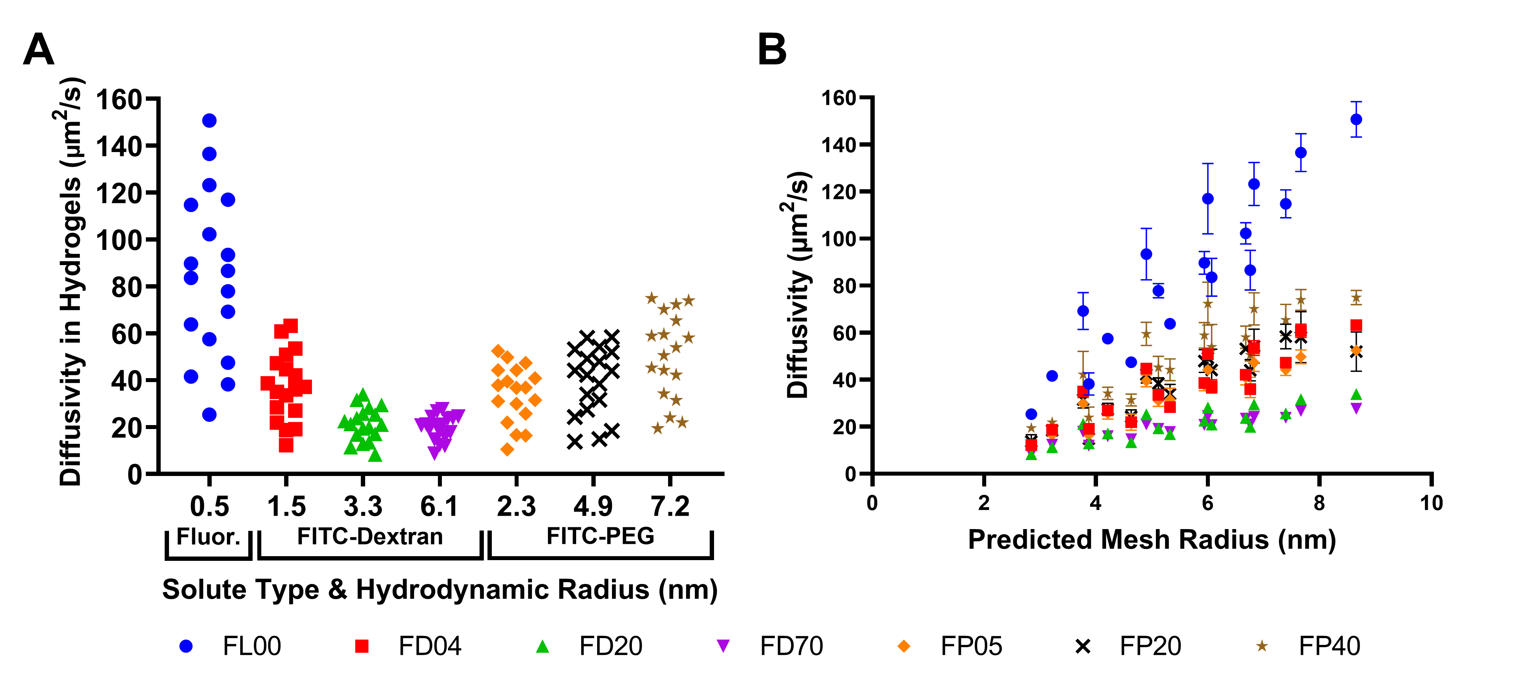
Caption for Figure:
Solute-dependent (A) and hydrogel-dependent (B) trends for solute diffusion in hydrogels. Error bars represent standard deviations (n = 18). Legend Key: FL00 is fluorescein, FD04 is 4 kDa FITC-dextran, FD20 is 20 kDa FITC-dextran, FD70 is 70 kDa FITC-dextran, FP05 is 5 kDa FITC-PEG, FP20 is 20 kDa FITC-PEG, and FP40 is 40 kDa FITC-PEG.

