Effects of attractive interfacial interactions on local, nanoscale stiffness of supported copolymer adhesive films
Sumeng Hu, Tong Wang, John Torkelson, Asghar Peera, Saswati Pujari, and Sipei Zhang
Northwestern University
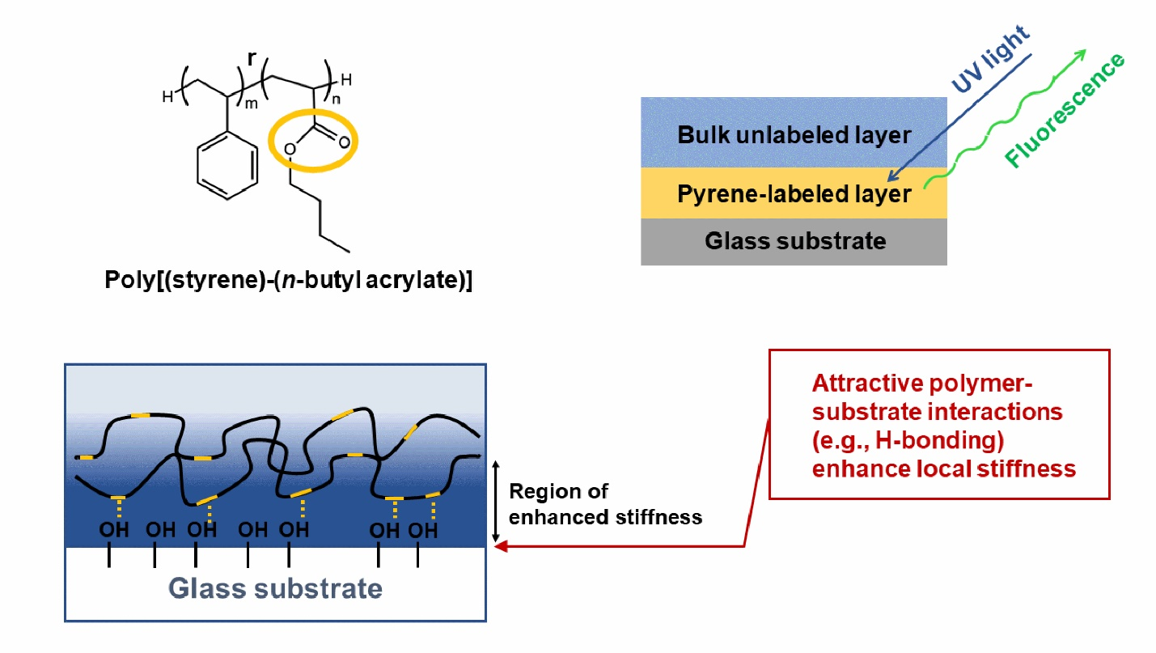
Nanoscale confinement of polymers in ultrathin films and near interfaces and free surfaces in bulk films and coatings can lead to substantial perturbations of properties relative to bulk polymers. Past studies have generally attributed the stiffness-confinement effect in supported films to the disparity between the rigidity of polymers and substrates; however, interfacial interactions can also be responsible for this behavior. Here, we report on the effects of interfacial interactions on local, nanoscale stiffness-confinement behavior. We have used a non-contact, self-referencing fluorescence method that is sensitive to local caging during the several hundred nanosecond excited-state lifetime of the fluorescence dye and thus provides a measurement related to a high-frequency modulus. We have isolated the effect of interfacial interactions from substrate rigidity and studied how interfacial interactions affect the stiffness of supported polymer films near glass substrates. We found that the stiffness of supported poly(styrene/n-butyl acrylate) (P(S/nBA)) random copolymer films is enhanced near the substrate interface, and the length scale over which the substrate perturbations propagate inside the film is highly dependent on the strength of the attractive hydrogen-bonding interactions between the hydroxyl groups on glass surface and the ester groups in nBA units. On hydrophilic glass, the length scale associated with the substrate perturbations increases from ~80 nm to ~180 nm when the nBA content in copolymers is increased from 59 mol% to 95 mol%. When the hydroxyl groups on a glass surface are partially or completely removed, the perturbation length scale decreases accordingly, with stronger impact being observed with nBA-richer systems. Thus, in addition to the disparity in polymer and substrate rigidities, our study shows that interfacial effects are another important underlying cause of stiffness-confinement effects of supported polymer films.

