Controlling oligomer structure to direct photopolymer network morphology
Tanner Grover and Allan Guymon
University of Iowa
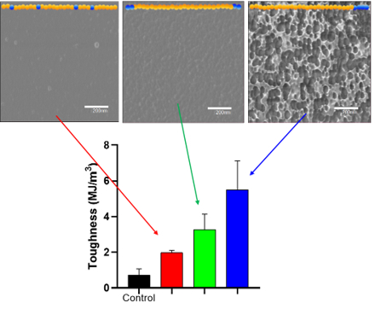
Photopolymerization has gained momentum as a facile technology for material fabrication due to multiple advantages relative to other polymerization processes including precise spatial control and low energy consumption. Although currently employed in additive manufacturing, and coating/adhesive applications, a predominant limitation that prevents expanded use is the lack of inherent toughness in photocured materials. Photopolymerization typically forms highly crosslinked networks stemming from monomers with fast gelation and cure speeds. The fast and relatively uncontrolled gelation hinders diffusion of reacting species and produces inhomogeneous crosslinking and highly irregular polymer networks. Engineered molecular structure of block copolymer additives in photocurable resins has been shown to direct organization of the monomer matrix and provide control over network structure. This direction is provided by amphiphilic properties of block copolymers and allows regulation over microphase morphology and material toughness. In this work, we develop block copolymers with functional pendant groups that direct network development in photocurable formulations while retaining processing advantages of traditional photopolymerization. Copolymers with unique architecture were constructed using controlled radical polymerization and combined with common photopolymerizable systems (e.g., methacrylates and epoxies). Specifically, photoiniferter polymerization was used to allow high control over copolymer structure such as molecular weight (MW), MW distribution, functional group placement, and block length ratio. Copolymer structure and concentration was explored for their effects on traditional photocurable systems by examining the thermomechanical behavior, surface morphology, and tensile properties of photocured thin films.

Top: AFM phase images of photopolymer networks composed of three different oligomer structures. Bottom: Tensile toughness of oligomer modified networks.

